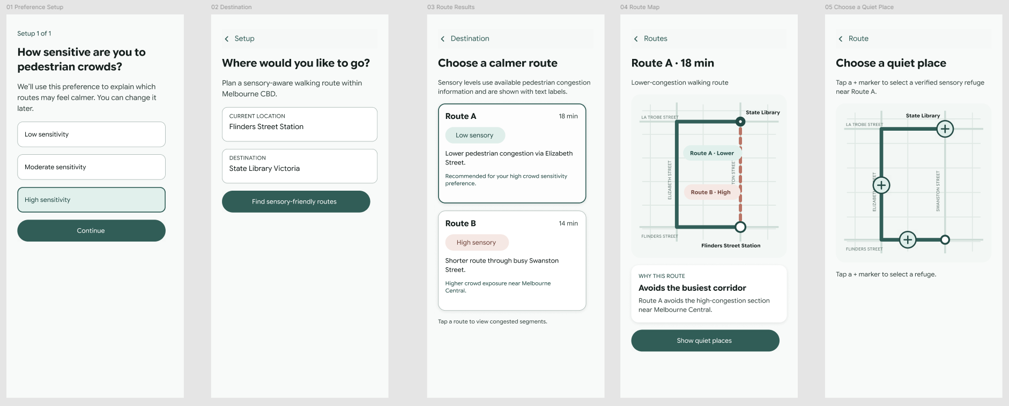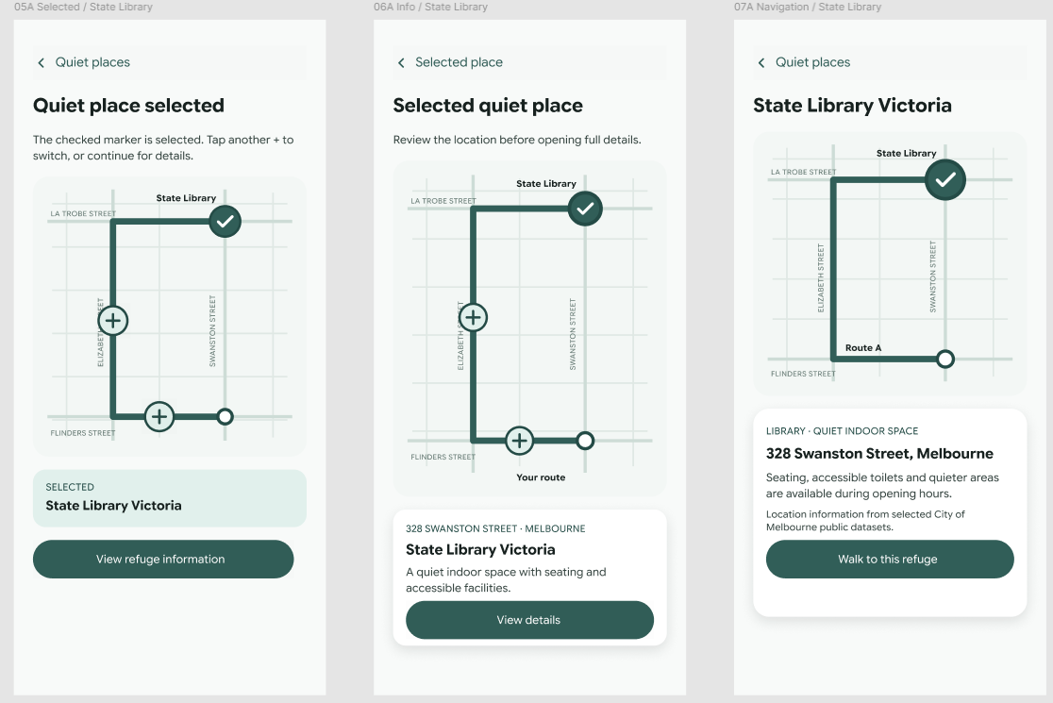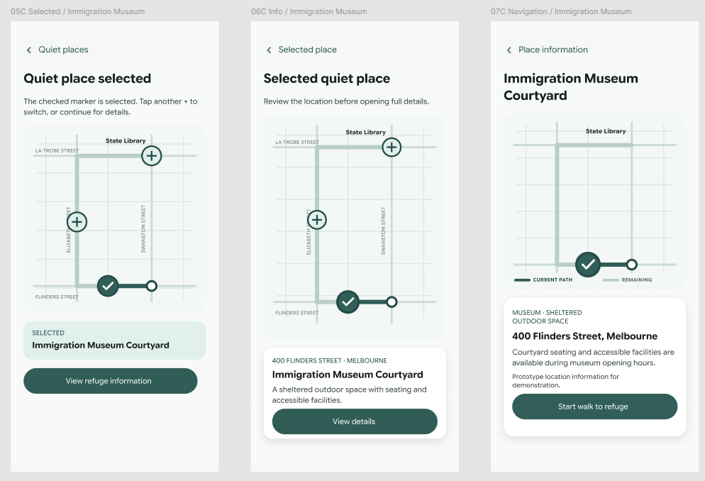
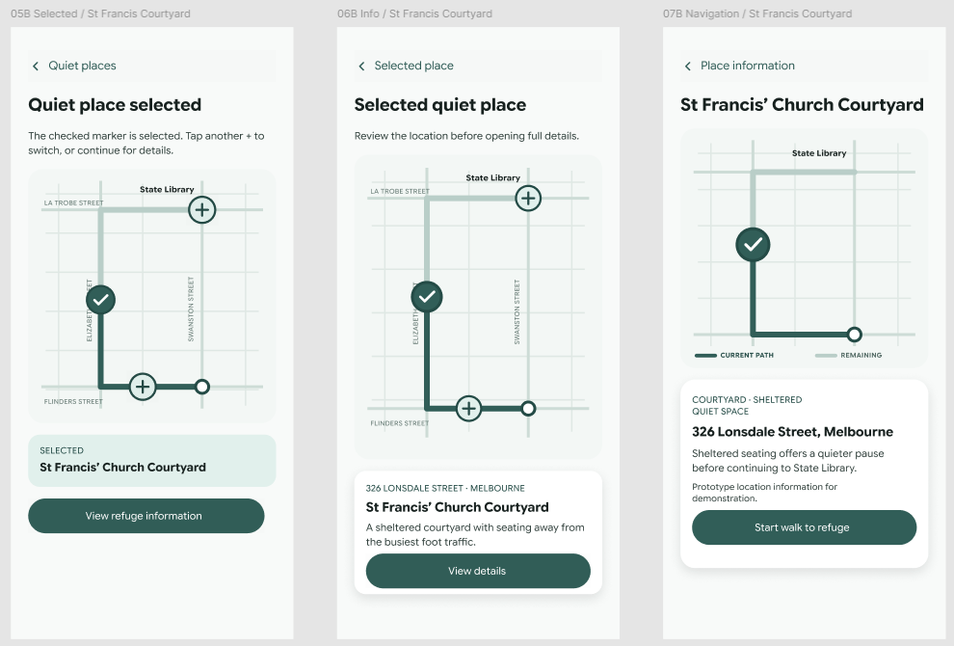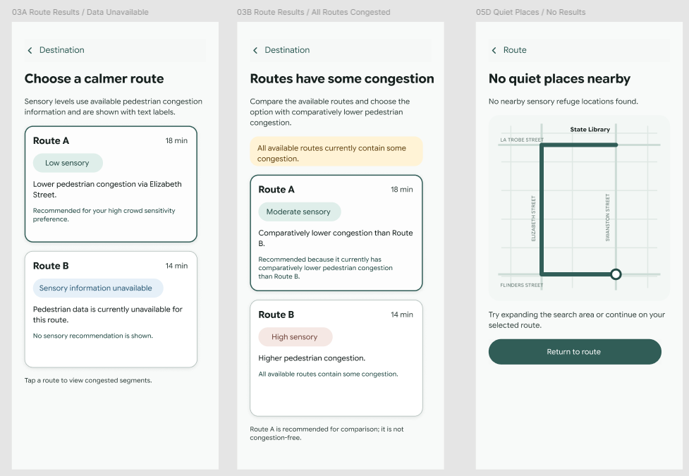
Epic 1 User Story 1.1 Sensory indicator
As a sensory-sensitive commuter, I want to see a sensory indicator (High or Low) for different routes, so that I can choose the path that feels safest and least overwhelming.
Data Sources
● Pedestrian Counts per Hour [data.gov.au]
● Sensor Locations [data.gov.au]
Acceptance Criteria
AC 1.1.1
Given the user has entered a valid destination,
When route options are displayed,
Then each route must show a clearly labelled “High Sensory” or “Low Sensory” indicator.
AC 1.1.2
Given a sensory indicator is displayed,
When the user views the route,
Then the indicator must be communicated using text and not colour alone.
AC 1.1.3
Given sensory data is unavailable for a route,
When the route is displayed,
Then the system must show “Sensory information unavailable”.

Epic 1 User Story 1.2
As a sensory-sensitive commuter, I want to avoid highly congested pedestrian corridors, so that I can reduce exposure to crowd-related stress.
Data Sources
● Real-time Pedestrian Counting System [melbourne.vic.gov.au], [data.gov.au]
Acceptance Criteria
AC 1.2.1
Given pedestrian-density data is available,
When the system analyses possible routes,
Then highly congested route segments must be identified.
AC 1.2.2
Given a lower-congestion alternative route is available,
When route options are displayed,
Then the system must recommend the lower-congestion route.
AC 1.2.3
Given all available routes contain congestion,
When route options are displayed,
Then the system must identify the comparatively lower-congestion route.

Epic 1 User Story 1.3
As a sensory-sensitive commuter during peak hour, I want alternative low-stimulation routes when crowd density exceeds my preferred threshold, so that I can avoid unexpected sensory overload.
Data Sources
● Pedestrian Counts per Hour [data.gov.au]
Prototype Acceptance Criteria
PAC 1.3.1
Given the user is setting their sensory preferences,
When the user selects a preferred crowd-sensitivity level,
Then the prototype must show that the selected preference will be used to assess route suitability.
PAC 1.3.2
Given crowd density exceeds the user’s preferred threshold,
When an alternative lower-stimulation route is available,
Then the prototype must demonstrate how the alternative route would be recommended to the user.
Scope Note
This user story is classified as a Could Have feature. It may be demonstrated in the high-level prototype but is not included in the committed build scope for the current onboarding iteration.
Full acceptance criteria will be refined before this user story enters an active development iteration.

